In this lesson we will learn about Drawing object and creating background in natron

so just rendering them without any import having to import or read them from a file or picture or a movie sequence

Foe now we have a black bg basically we are just viewing nothingness

Lets chaange our background to certain color to do that lets create a constant

so we go to image node and then set it to constant so in node graph we have a constant attached to viewer

as shoen in node gaph below

Now iewer node is still not showing anything but actually it is a black color

Now to change it we go to its properties

and then to color increase the slider

so that the screen looks white like below

Now you can set manual colors by

clicking on the marked below

It is not an object or rectangle that you can change we are looking at the color we set for our viewer

we set it to blue for now

So if we want to see something here lets say we select rectangle by going to draw and then to Rectangle

Now suppose we connect our viewer to Rectangle node

then it mayu look same but see its property

as shown below which are different or more than the viewer as shown below

and we can by frag and drop move it around

whereas the constant is just a set the whole screen which you can't really change Its not really an object like rectangle where we can move around it or scale the size

Now we set the color of rectange to green as sheon below

but we did not see the blue bg we set with constant so we can o so with the help of merge node

and connect B to constant dso it will eb in bg and rectangle to A so it will be in front

The rectangle changes its shade due to bg (I don't know)

After retying no error found like above

So constant is a bg and the rectangle is at the top of it

2:08

We wnat to read in some text

We go to draw in toolbar and then to Text

Now to make all the object and text together we add another merge node

whose b is connected to another merge node and a is connected to text node as shown below

and now we can see our constatn and rectangel and also text

as shown below

We make the text Hello World

Constant does not look good so we remove it

and in place of it we use new node that we will learn that is noise node

We can get it by going to draw in the toolbar and then to noise as shown below

Now in viewer node you can see its kibnd of subtle but created a noise

Now in noise property you can set its sigma which control its intensity

Now if we play it actually play like old school like noise interference (whihc you used to see in old tv)

Now delete noise node and we will another node that is plasma

we replace noise with the plasma as shown below

Note:-

I think node previos linked node to it can influence it (Who knows)

In viewer node you can see

When you play it just shows above nothing happens

but it is because we are looking at a constant

but to make it dynamic go to its property

and uncheck static select

Now if you play it then different color shoen in different frames make it dynamic (random color seeds effects)

Now we see its property

I think by alpha we set the intensity of colors

and beta maybe make the edges of different color sharper

and scale tell us that how much the seed is large in the viewer(who knows)

Let learn and try radial node as shown below

Now in viewer we have a radial shape that is starting with a white and fading towards a color that is black by default

Now in its property in color 0 we set

the color the radial will fade to and in color 1 we set the color for the starting

We set the color 0 we set the radial such that it is fadng ot green

we are not animating anything for now we are just shoeing it to you

7:10

Now comes ramp

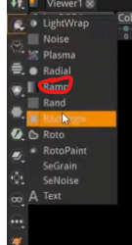

We connect the ramp to merge node as shown below

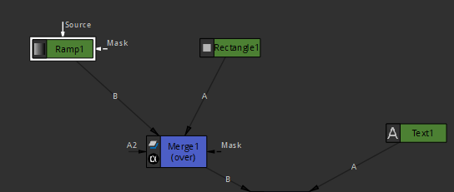

Now the ramp works similar to radial but this time we control it by dragging the point 1 and point 2

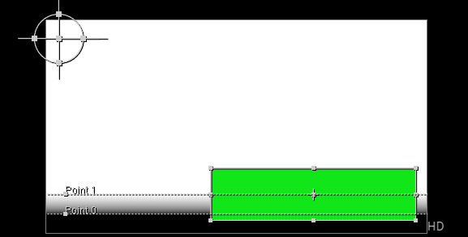

I have observed that if you drag any point left and right then the line inclination will change and if you can move it up and down by dragging

Point 1 set the range from which the gradient will start and point 2 tell when it will end and below it everything will be color of the point 2 that is color 2

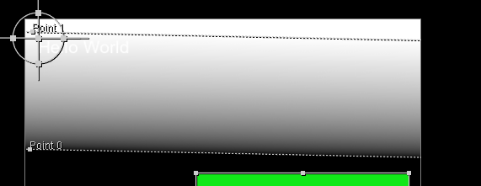

You can also set it by its properties by setting the points x and y position

We can also change its color

As shown below

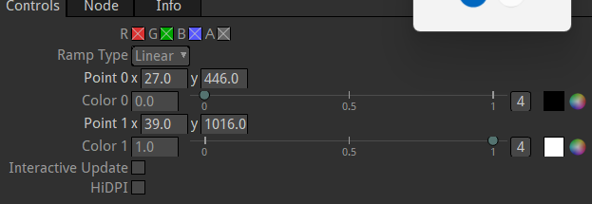

If we change color 1 to red and color 0 to green then it will look like below

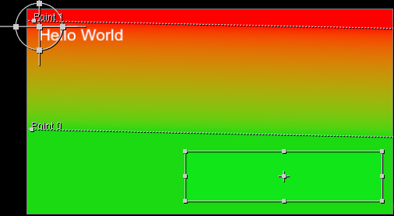

Now we will see rand

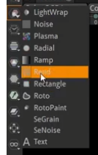

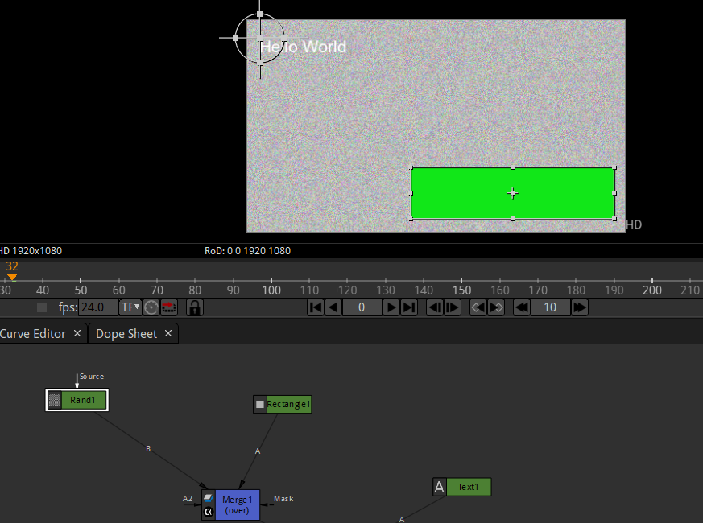

It just give randome effects like noise so it is similar to noise

So when you render things like this play ahead with all these

We will do roto in another lesson

It is used to draw your custom mask

And you can trace anything with this

Like drawing wolf (who knows) and also roto paint we will cover these later

We see Se Grain and Unfortunately teacher don’t know about it so he will teach it later on

We see Color bar

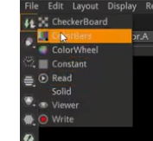

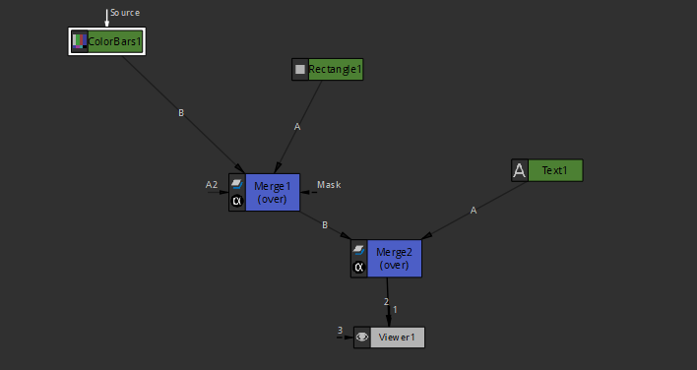

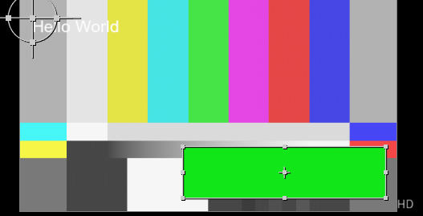

You can see all the color bar because of it

It has many properties like Bar intensity

Through which you can set its brightness or intensity

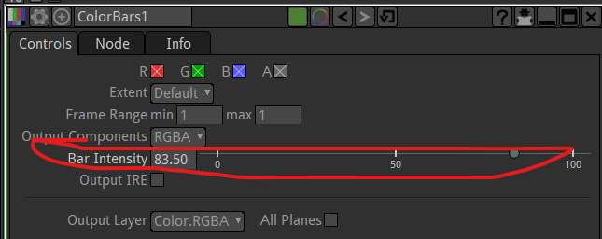

Now we have a checker board

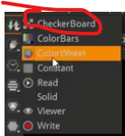

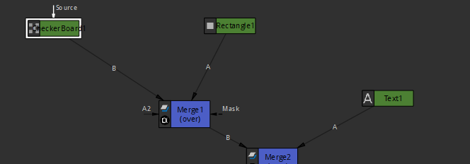

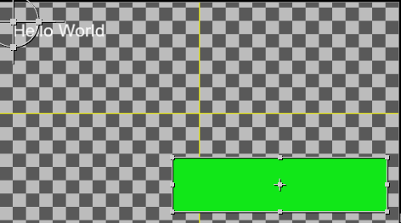

You often see thso checker board for transparent background

We can change the size of the checkerboard and change color of individual checkerboard

So any way that’s rendering out

9:55

Now we see shaderToy It actually render

Shader tool is like moving background as shown below

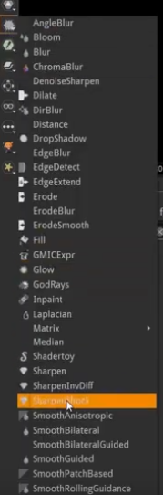

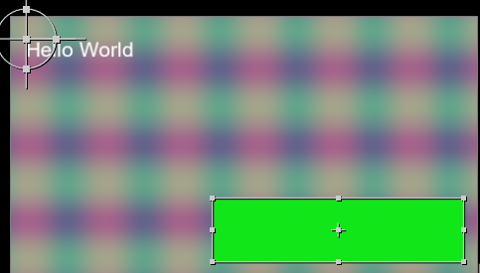

Frame 1

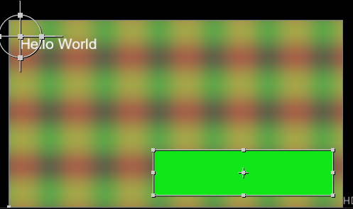

Frame 100

We can explore its properties to modify it so that we can make the background show different things beside color

So there are some ways you can render in natron

So now we will see this in another lesson